Deliverable #3

Company: TranspoLogic

Product: FleetConnect

Group members:
Ahmad Habib 23i-0011
Rayyan Qamar Hashmi 23i-0815
Umer Naseer 23i-0663

Section: CS-5B

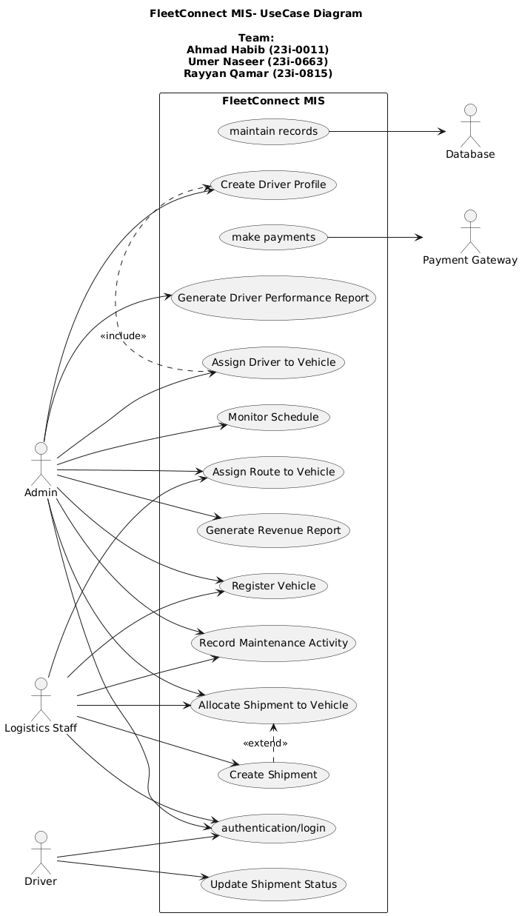

FleetConnect: Fully Dressed Use Cases

Use Case 1: Register Vehicle
Use Case Name | Register Vehicle
Scope | FleetConnect MIS
Level | User Goal
Primary Actor | Admin/Logistics Staff
Stakeholders and Interests | Admin: wants accurate vehicle records.  Company: needs updated fleet availability.
Preconditions | Admin must be logged in.
Postconditions | Vehicle is stored in the system with status available.
Main Success Scenario
  Actor Action | System Response
  Admin selects 'Register Vehicle.' | System prompts for vehicle details.
  Admin enters registration info and submits. | System stores vehicle in database.
Extensions | Missing/invalid data → system requests correction.

Use Case 2: Create Driver Profile
Use Case Name | Create Driver Profile
Scope | FleetConnect MIS
Level | User Goal
Primary Actor | Admin
Stakeholders and Interests | Drivers: want their credentials stored.  Company: requires valid driver details.
Preconditions | Admin must be logged in.
Postconditions | Driver profile is created in system.
Main Success Scenario
  Actor Action | System Response
  Admin selects 'Create Driver Profile.' | System shows profile form.
  Admin enters driver info (license, hours). | System validates and saves profile.
Extensions | License invalid → system rejects entry.

Use Case 3: Assign Driver to Vehicle
Use Case Name | Assign Driver to Vehicle
Scope | FleetConnect MIS
Level | User Goal
Primary Actor | Admin
Stakeholders and Interests | Driver: wants fair workload.  Admin: needs correct allocation.
Preconditions | Driver and vehicle must exist and be available.
Postconditions | Driver assignment stored in database.
Main Success Scenario
  Actor Action | System Response
  Admin selects driver and vehicle. | System checks availability.
  Admin confirms assignment. | System stores assignment.
Extensions | Vehicle under maintenance → assignment not allowed.

Use Case 4: Create Shipment
Use Case Name | Create Shipment
Scope | FleetConnect MIS
Level | User Goal
Primary Actor | Logistics Staff
Stakeholders and Interests | Customer: wants shipment delivered.  Company: wants cargo records.
Preconditions | System must have available vehicle.
Postconditions | Shipment record created.
Main Success Scenario
  Actor Action | System Response
  Staff selects 'Create Shipment.' | System shows shipment form.
  Staff enters cargo details. | System saves shipment.
Extensions | No available vehicles → notify staff.

Use Case 5: Allocate Shipment to Vehicle
Use Case Name | Allocate Shipment to Vehicle
Scope | FleetConnect MIS
Level | User Goal
Primary Actor | Admin/Staff
Stakeholders and Interests | Drivers: want clear assignments.  Company: wants efficient vehicle usage.
Preconditions | Shipment and vehicle must exist.
Postconditions | Shipment assigned to vehicle.
Main Success Scenario
  Actor Action | System Response
  Admin selects shipment. | System displays available vehicles.
  Chooses vehicle. | System confirms allocation.
Extensions | Vehicle capacity exceeded → system prevents allocation.

Use Case 6: Update Shipment Status
Use Case Name | Update Shipment Status
Scope | FleetConnect MIS
Level | User Goal
Primary Actor | Driver
Stakeholders and Interests | Customer: wants visibility of shipment.  Admin: monitors delivery progress.
Preconditions | Shipment must be active.
Postconditions | Status updated (in-transit, delivered).
Main Success Scenario
  Actor Action | System Response
  Driver logs in. | System shows active shipments.
  Driver updates shipment status. | System stores update.
Extensions | Invalid shipment ID → error message.

Use Case 7: Assign Route to Vehicle
Use Case Name | Assign Route to Vehicle
Scope | FleetConnect MIS
Level | User Goal
Primary Actor | Admin/Staff
Stakeholders and Interests | Driver: needs correct route.  Company: requires efficient scheduling.
Preconditions | Vehicle and route exist.
Postconditions | Vehicle is linked to route.
Main Success Scenario
  Actor Action | System Response
  Admin selects vehicle. | System retrieves available routes.
  Admin assigns route. | System updates record.
Extensions | Route not found → system error.

Use Case 8: Monitor Schedule
Use Case Name | Monitor Schedule
Scope | FleetConnect MIS
Level | User Goal
Primary Actor | Admin
Stakeholders and Interests | Admin: tracks ongoing trips.  Customer: expects timely delivery.
Preconditions | Trips scheduled.
Postconditions | Schedules displayed.
Main Success Scenario
  Actor Action | System Response
  Admin opens 'Monitor Schedule.' | System shows current trip schedules.
Extensions | No trips scheduled → display empty.

Use Case 9: Record Maintenance Activity
Use Case Name | Record Maintenance Activity
Scope | FleetConnect MIS
Level | User Goal
Primary Actor | Admin/Staff
Stakeholders and Interests | Admin: keeps vehicles safe.  Company: wants minimized downtime.
Preconditions | Vehicle exists.
Postconditions | Maintenance log updated.
Main Success Scenario
  Actor Action | System Response
  Staff selects vehicle. | System shows maintenance form.
  Records maintenance work. | System saves record.
Extensions | Invalid entry → request correction.

Use Case 10: Generate Revenue Report
Use Case Name | Generate Revenue Report
Scope | FleetConnect MIS
Level | User Goal
Primary Actor | Admin
Stakeholders and Interests | Admin: wants financial data.  Company: needs revenue tracking.
Preconditions | Financial data must exist.
Postconditions | Report generated.
Main Success Scenario
  Actor Action | System Response
  Admin selects 'Generate Revenue Report.' | System compiles data.
  Admin views report. | System displays it.
Extensions | Missing data → mark report incomplete.

Use Case 11: Generate Driver Performance Report
Use Case Name | Generate Driver Performance Report
Scope | FleetConnect MIS
Level | User Goal
Primary Actor | Admin
Stakeholders and Interests | Admin: evaluates driver performance.  Drivers: want fair assessment.
Preconditions | Driver data must exist.
Postconditions | Report generated.
Main Success Scenario
  Actor Action | System Response
  Admin selects driver. | System compiles trip and workload history.
  Admin requests report. | System displays report.
Extensions | No data → notify admin.

Use Case 12: Authentication
Use Case Name | Authentication
Scope | FleetConnect MIS
Level | User Goal
Primary Actor | Admin, Logistic Staff, Drivers
Stakeholders and Interests | All above mentioned entities need to login inorder to operate the system.
Preconditions | User needs to have internet and device to access the system
Postconditions | User logged in.
Main Success Scenario
  Actor Action | System Response
  User enters credentionals | System accesses the database to check for pre-existing records.
   | System displays dashboard.
Extensions | No data → show error.

